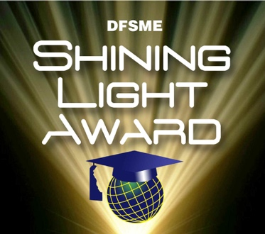
DFSME Awardee Recognition Nomination Form
Name of Teacher / Awardee / School District:

Name of Nominator, Title, contact information and, if applicable, School District:

About the Awardee:

About the Nominee:

Connection to DFSME Mission to strengthen and retain high performing STEM educators,
and prepare DE students to be informed citizens and competitive in the global workforce:

How is it Replicable in Nature? (how is this a model for others in the future?):

Awardee’s Exemplary Highlights, background, offices held, other awards, experience, etc.:

Anyone may nominate a STEM Educator for the Shining Light Award.
Honorees receive a $100 gift card and mag flashlight. Email completed form to drses48@aol.com or Michelle.Kutch@bsd.k12.de.us.

